EXPT NO:2 | LOAD AND VISUALIZE A DATASET USING TABLEAU and PowerBI
DATE: 10.07.2026

PRE-LAB QUESTIONS (PROVIDE BRIEF ANSWERS TO THE FOLLOWING QUESTIONS)
- Why is Tableau a preferred tool for data visualization?
Tableau is a preferred Business Intelligence tool because it provides an intuitive drag-and-drop interface for creating interactive and visually appealing dashboards. It can connect to multiple data sources, handle large datasets efficiently, and supports a wide variety of charts and graphs. Tableau enables users to analyze complex data quickly without extensive programming knowledge, making it suitable for business analysis and decision-making.

- What is the primary use of a line chart in data analysis?
A line chart is mainly used to display trends and patterns in data over a period of time. It helps users identify increases, decreases, seasonal variations, and long-term growth. In business analytics, line charts are commonly used to visualize sales, revenue, stock prices, and other time-series data, making it easier to understand changes and predict future trends.

- When would you use a tree map instead of a bar chart?
A tree map is used when there are many categories and sub-categories that need to be compared within a limited space. It displays hierarchical data using rectangles whose sizes represent values. Unlike a bar chart, which compares values along an axis, a tree map efficiently shows the proportion of each category relative to the whole, making it useful for analyzing sales distribution across multiple product categories.

- What is the significance of filters in Tableau visualizations?
Filters allow users to display only the data relevant to their analysis by excluding unnecessary information. They improve dashboard interactivity by enabling users to focus on specific categories, regions, dates, or other dimensions. Filters also make visualizations easier to interpret and support dynamic exploration of data without modifying the original dataset.

- How does Tableau handle geographic data for visualizations?
Tableau automatically recognizes geographical fields such as Country, State, City, and Postal Code. It assigns geographic roles to these fields and uses built-in mapping capabilities to create interactive maps. Users can visualize sales, profit, or other measures geographically using colors, sizes, and labels, helping identify regional trends and performance differences.

IN-LAB EXERCISE:
OBJECTIVE:
To load a dataset into Tableau, create a variety of visualizations, and derive insights from the data using different chart types available in Tableau.
PROCEDURE:
Dataset Selection:
Use the Global Superstore Sales Dataset (available on Kaggle or Tableau's sample datasets).
Ensure the dataset includes fields like Order Date, Category, Region, Sales, Profit, and Customer Segment.
Data Loading:
Open Tableau and connect to the dataset.
Review the dataset structure, field data types, and missing values.
Chart Creations (Step-by-Step):
- Bar Chart:
Objective: Compare total sales by region and category.
Plot Region on the x-axis and Sales on the y-axis.
Add Category as a color dimension.
- Line Chart:
Objective: Visualize sales trends over time.
Place Order Date on the x-axis and Sales on the y-axis.
Set granularity to Month and color by Category.
- Pie Chart:
Objective: Show sales distribution by product category. Assign Category as the dimension and Sales as the measure.
- Scatter Plot:
Objective: Examine the relationship between profit and sales.
Plot Profit on the x-axis and Sales on the y-axis.
Use Sub-Category as the color dimension.
- Heatmap:
Objective: Compare sales across categories and regions.
Use Region and Category as dimensions. Use Sales as the measure and apply color coding.
- Geographical Map:
Objective: Visualize total sales by country.
Set Country as the geographical field. Use Sales to define size and color gradients.
- Tree Map:
Objective: Display sales distribution by category and sub-category.
Use Category and Sub-Category as dimensions, and Sales as the measure.
Customization and Interactivity:
Add filters to explore data subsets interactively (e.g., by year, region, or category).
Include annotations, labels, and formatting for clarity.
Dashboard Creation:
Combine all charts into a single dashboard to present a cohesive story.
Add interactive filters and tooltips for dynamic exploration.
Experiment Dataset:
Global Superstore Sales Dataset
Source: https://www.kaggle.com/datasets/apoorvaappz/global-super-store-dataset
Fields Used:
Order Date
Region
Category
Sub-Category
Sales
Profit
Country

Screenshot of the dashboard in tableau
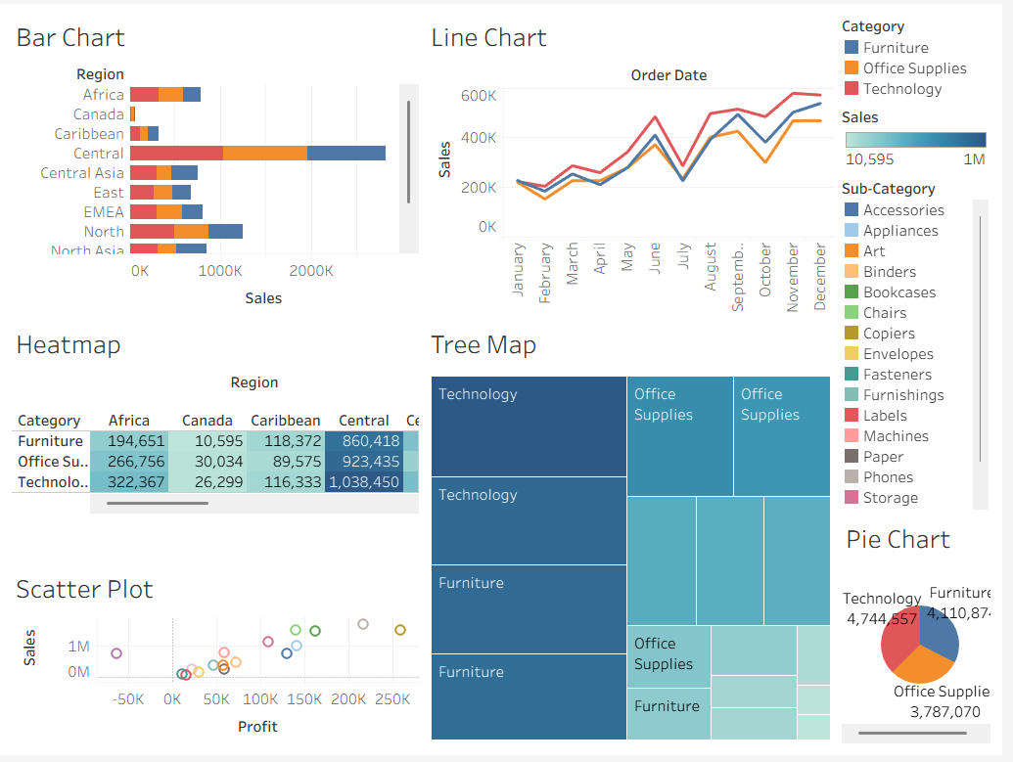

Screenshot of the dashboard in Power BI
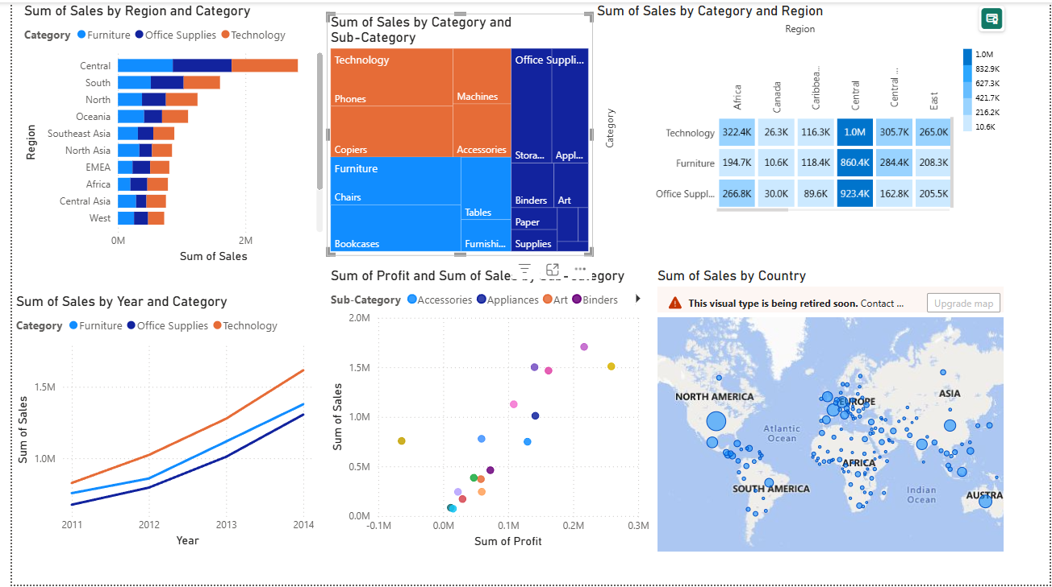

POST-LAB QUESTIONS (PROVIDE BRIEF ANSWERS TO THE FOLLOWING QUESTIONS)
Bar Chart:
What regions had the highest and lowest total sales?
The bar chart showed that the Central region generated the highest total sales among all regions, while Canada recorded the lowest sales. Other regions such as South, North, and Oceania also contributed significantly but remained below Central. The visualization made it easy to compare regional performance and identify areas where sales were relatively weaker.

How does the performance of categories vary across regions?
The analysis showed that Technology generally contributed the highest sales in most regions, followed by Office Supplies and Furniture. Although the overall sales varied by region, Technology consistently performed well across different markets. Furniture showed comparatively lower sales in several regions, indicating varying customer demand and product preferences.

Line Chart:
Identify the month with peak sales.
The line chart indicated that November recorded the highest sales during the year. Sales gradually increased after the middle of the year, reached their maximum in November, and remained relatively high in December. This trend suggests increased customer purchases during the holiday and festive shopping season, which is common in retail businesses.

Which category shows consistent growth in sales over time?
Among the three categories, Technology showed the most consistent growth throughout the year. Although there were small fluctuations in monthly sales, the overall trend remained upward. Office Supplies and Furniture also experienced growth but displayed greater variations, making Technology the most stable performing category.

Pie Chart:
Which category contributes the most to overall sales?
The pie chart revealed that Technology contributed the largest share of total sales, followed by Furniture and Office Supplies. The visualization clearly showed Technology occupying the largest portion of the chart, indicating strong customer demand and higher revenue generation compared to the other product categories.

Are there any categories with negligible sales contributions?
No category had a negligible contribution to total sales. All three categories—Technology, Furniture, and Office Supplies—made significant contributions to overall revenue. However, Office Supplies contributed slightly less than the other two categories, while Technology remained the leading contributor.
Scatter Plot:
Is there a noticeable correlation between profit and sales?
Yes, the scatter plot showed a generally positive relationship between profit and sales. Products with higher sales often generated higher profits, although some points indicated high sales with relatively low profit due to discounts or lower profit margins. The visualization helped identify profitable as well as less profitable product groups.
Which sub-category shows the highest sales but low profit?
The scatter plot indicated that Tables had relatively high sales but comparatively low profit. This suggests that despite generating substantial revenue, the profit margins were lower, possibly because of higher discounts, production costs, or competitive pricing strategies.

Heatmap:
Which region-category combination has the highest sales?
The heatmap showed that the Central region – Technology category combination recorded the highest sales. The darkest color intensity highlighted this combination, making it easy to identify the strongest performing region and category. Other high-performing combinations included South–Technology and North–Office Supplies.
Identify any regions with poor sales performance across all categories.
The heatmap indicated that Canada consistently recorded lower sales across all product categories compared to other regions. Although sales were present, the lighter color shades suggested weaker overall performance. This information could help businesses identify markets that may require additional marketing or sales strategies.
Geographical Map:
Which country has the highest total sales?
The geographical map showed that the United States had the highest total sales among all countries represented in the dataset. Larger bubble sizes and darker color intensity indicated stronger sales performance. Several other countries also contributed significantly, but none exceeded the sales generated by the United States.
Are there regions with minimal or no sales?
Yes, the map indicated that a few countries had relatively low sales compared to major markets. These locations were represented by smaller bubbles and lighter colors. However, most regions included in the dataset recorded at least some sales, showing that the business has a broad global customer base.

Tree Map:
Which sub-category dominates the sales in each category?
The treemap showed that Phones dominated the Technology category, Chairs dominated Furniture, and Binders dominated Office Supplies. These sub-categories occupied the largest areas within their respective categories, indicating that they contributed the highest sales among the available products.
Are there any sub-categories with unexpectedly low sales?
Yes, sub-categories such as Fasteners, Labels, and Supplies occupied relatively small areas in the treemap, indicating lower sales. Their contribution was much smaller compared to major sub-categories like Phones and Chairs. This suggests that these products have comparatively lower customer demand.

Dashboard:
What insights can you derive when combining all visualizations?
Combining multiple visualizations provided a comprehensive understanding of business performance. The dashboard highlighted regional sales trends, monthly sales growth, product category contributions, geographical distribution, and profitability. It became easier to identify top-performing regions, profitable product categories, and sales patterns. The integrated dashboard enabled faster and more effective decision-making compared to analyzing individual charts separately.
How do filters enhance the utility of the dashboard?
Filters make the dashboard interactive by allowing users to focus on specific regions, categories, dates, or customer segments. They help users compare different subsets of data without creating separate reports. Interactive filtering improves data exploration, supports faster analysis, and enables decision-makers to identify trends, opportunities, and performance differences more efficiently.

ASSESSMENT

Description |  | Max Marks | Marks Awarded
Pre Lab Exercise |  | 5
In Lab Exercise |  | 10
Post Lab Exercise |  | 5
Viva |  | 10
 | Total | 30
 |  | Faculty Signature

